World Happiness Report Analysis and Findings

Bushra Naveed
Department of Computer Science; San Jose State University
CS 133: Introduction to Data Visualization
Dr. Jessica Westfall
May 5, 2025

Inspiration
In recent years, global attention has increasingly focused on mental health, quality of life, and what it truly means to be “happy.” Our team was inspired by a desire to understand how diverse factors including economic, social, and emotional, contribute to national happiness over time. In particular, we were curious about how changing political climates, including trust in government and freedom, may impact public well-being across countries. By analyzing global data from 2005 to 2021, we hope to uncover patterns that reveal how societies evolve and what makes people flourish or falter.

Background on Dataset
The dataset used in this analysis was sourced from Github and contains global happiness data collected between 2005 and 2021. It includes 2,089 records and 12 columns, covering various economic, social, and emotional well-being indicators.
The columns in the dataset are as follows:
- Country
- Year
- Happiness
- Wealth
- Social Support
- Life Expectancy
- Freedom
- Generosity
- Perceived Corruption
- Positive Affect
- Negative Affect
- Trust in Government
Most variables in the dataset are normalized to a 0–1 scale, with the exception of a few:
- Happiness is measured on a 0–8 scale, representing overall life evaluation or ladder score (0 being the worst possible life and 8 the best).
- Wealth is measured as the logarithm of GDP per capita, typically ranging from approximately 5 to 12.
- Life Expectancy is measured as healthy life expectancy at birth, with values generally between 6 and 75 years.
Positive Affect represents the average frequency of positive emotions such as happiness, laughter, and enjoyment, measured through survey responses to questions like “Did you experience the following feelings during a lot of the day yesterday?”. This variable is defined differently depending on the survey wave but generally falls within a 0–1 range.
Negative Affect captures the frequency of negative emotions such as worry, sadness, and anger, also based on survey responses. Like a positive effect, it is scaled from 0 to 1.
Below is a summary of the key variables, their descriptions, and typical value ranges:
Column | Description | Typical Scale
Happiness | Overall life evaluation (ladder score) | 0 – 10
Wealth | Log of GDP per capita (normalized) | ~5 – 12
Social Support | Proportion of people with someone to count on | 0 – 1
Life Expectancy | Healthy life expectancy at birth | ~6 – 75
Freedom | Perceived freedom to make life choices | 0 – 1
Generosity | Donations to charity (scaled) | 0 – 1 (low ~0.1)
Perceived Corruption | Perception of government/business corruption | 0 – 1 (low = better)
Positive Affect | Frequency of positive emotions (laugh, enjoyment, etc.) | 0 – 1
Negative Affect | Frequency of negative emotions (worry, sadness, anger) | 0 – 1
Trust in Government | Confidence in national government | 0 – 1 (often low)

Data Preprocessing
The dataset required a series of preprocessing steps to address missing values, ensure data consistency, and prepare the features for machine learning. Our primary goal was to retain as much valuable data as possible while applying context-sensitive imputation techniques.

Handling Missing Values

Column | Missing Values (%) | Missing Count
Country | 0.00% | 0
Year | 0.00% | 0
Happiness | 0.00% | 0
Wealth | 1.29% | 27
Social Support | 0.62% | 13
Life Expectancy | 2.78% | 58
Freedom | 1.53% | 32
Generosity | 3.83% | 80
Perceived Corruption | 5.41% | 113
Positive Affect | 1.15% | 24
Negative Affect | 0.77% | 16
Trust in Government | 10.34% | 216

A comprehensive audit of missing data was performed across all columns. The breakdown of missing values is as follows:
- Given that ‘Trust in Government’ had the highest proportion of missing data (10.34%) and the variable was found to be approximately normally distributed, we imputed missing values using the mean. This approach preserves the distributional characteristics without introducing skew.
- For ‘Perceived Corruption’, which displayed a right-skewed distribution, we replaced missing values with the median based of that country to reduce the influence of outliers and maintain central tendency.
All remaining rows that still contained missing values after this targeted imputation were removed from the dataset to ensure data quality and model stability.

Additional Preprocessing Steps
- Duplicate Records: The dataset was checked for duplicate entries, and none were found.
- Country Integrity: The ‘Country’ column was confirmed to contain only unique, valid country names with no anomalies.
- Final Dataset Size: After preprocessing, the dataset was reduced from 2,089 records to 1,910 records, resulting in 91.84% data retention. Only 8.16% of the original data was discarded.
These steps ensured the dataset was both clean and representative, providing a solid foundation for exploratory analysis and machine learning modeling.

Data Exploration and Visualization

We began our analysis by exploring the relationships between happiness and various socioeconomic and emotional indicators using both static and interactive visualizations. These visualizations helped guide our hypotheses, model design, and feature selection.

Pairplot: Initial Correlation Inspection
Our first step was to use a pairplot to observe potential correlations between happiness and other key numerical variables.
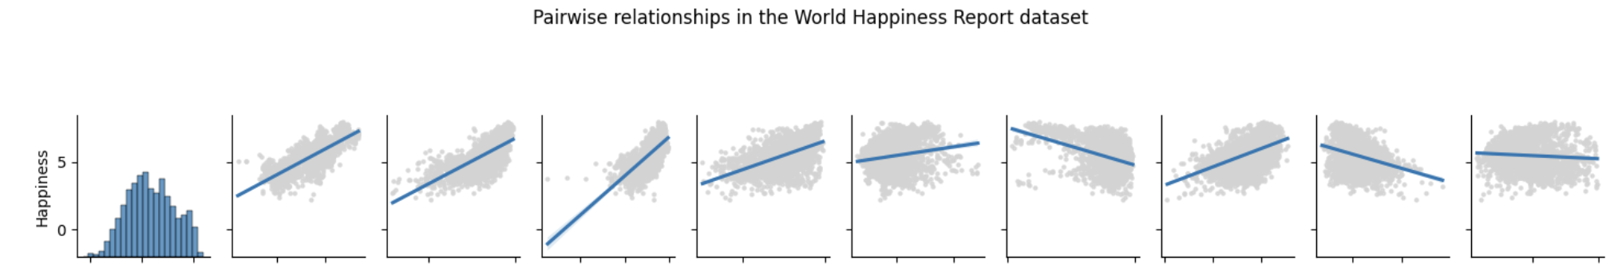
This gave us a general sense of linear relationships:
- Strong Positive Correlations:
  - Wealth (GDP per Capita)
  - Social Support
  - Life Expectancy
- Weak Positive Correlations:
  - Freedom
  - Generosity
  - Positive Affect
- Weak Negative Correlations:
  - Perceived Corruption
  - Negative Affect
- No Correlation:
  - Trust in Government
This helped form the basis for more targeted exploratory questions.

Q1: What features are most strongly correlated with happiness?
To quantify these relationships, we visualized a correlation matrix of key numerical variables:
sns.heatmap(df[numeric_cols].corr(), annot=True, cmap="coolwarm")

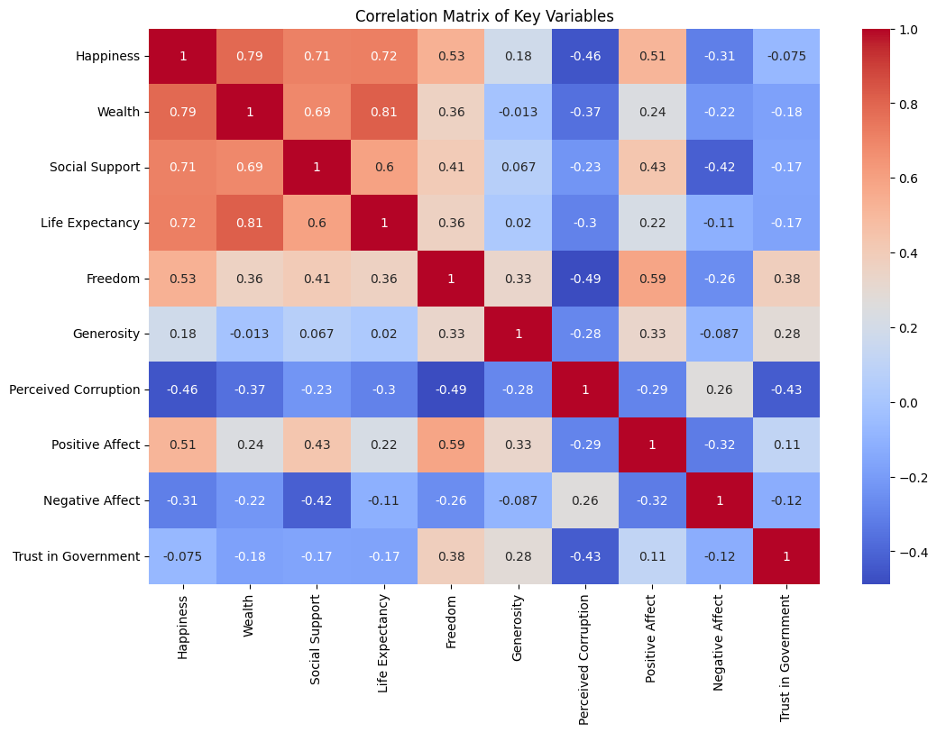
Observations:
- Happiness had the strongest correlations with ‘Wealth’, ‘Social Support’, and ‘Life Expectancy’, supporting our pairplot observations.
- ‘Trust in Government’ showed near-zero correlation with happiness.

Q2: Do countries with higher trust in government report higher happiness?
We created an interactive dual-line plot using Plotly to explore how happiness and trust in government varied over time for each country. A dropdown menu allows the user to toggle between countries.

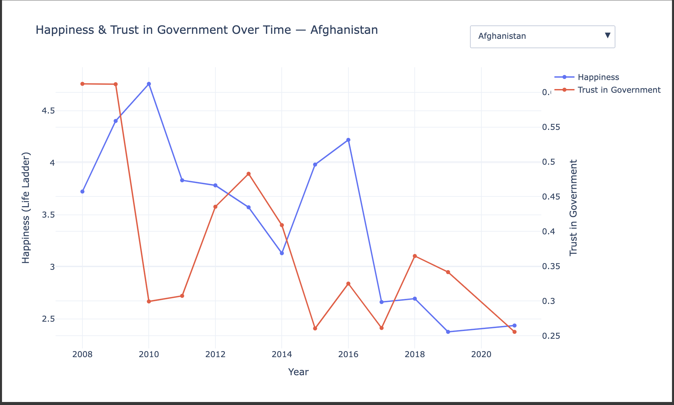
Observations:
- In most countries, ‘Trust in Government’ did not appear to significantly influence ‘Happiness’.
- Exception: In countries like Afghanistan, the two trends showed noticeable alignment indicating that in some contexts, institutional trust may influence happiness.

Q3: Which countries report the highest happiness scores over the last five years?
We built an interactive bar chart with Plotly to show average happiness scores from the last five years 2017 to 2021 across various countries. Users can hover over the bars to see that country’s respective average wealth (GDP per capita), socal support (rated on a scale of 0-1), and life expectancy (in years).
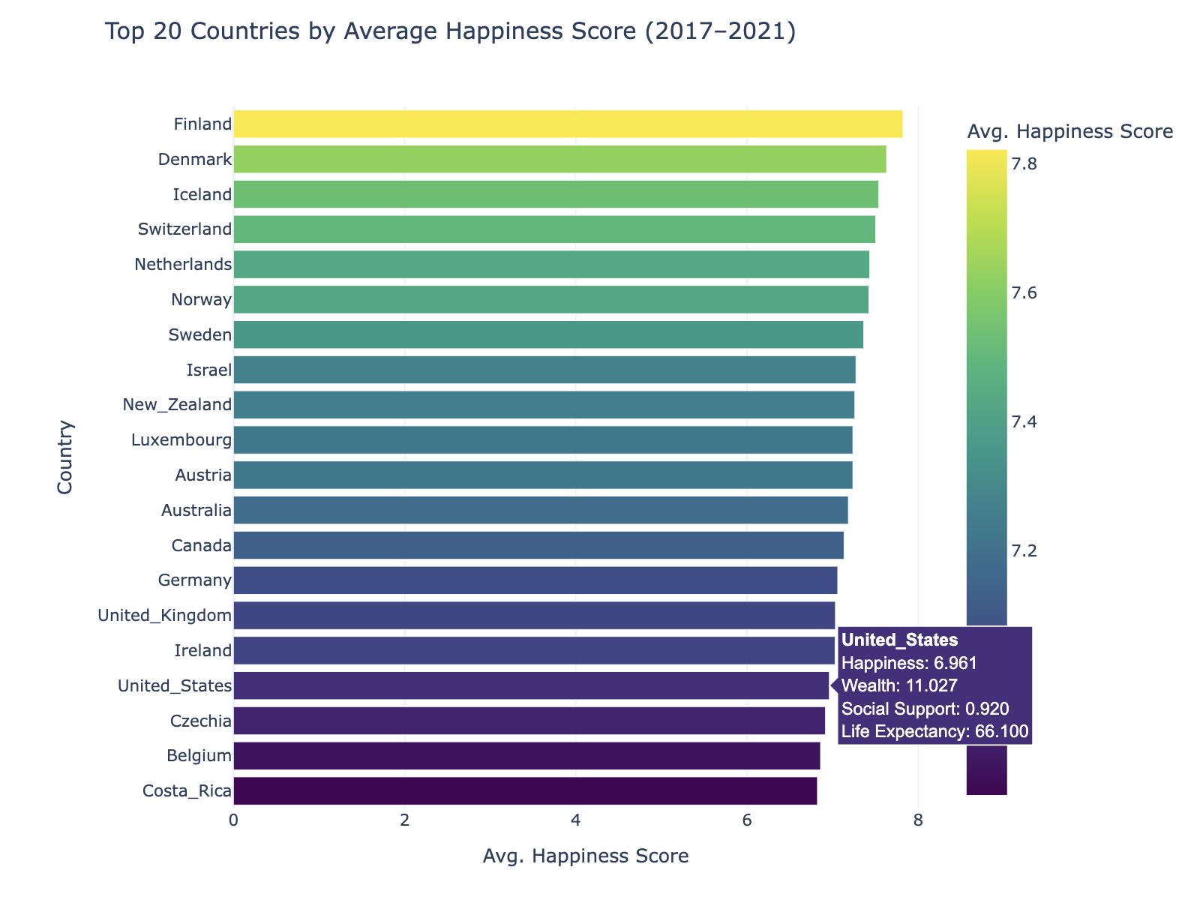
Observations:
- Nordic countries dominate the top of the ranking, with Finland, Denmark, and Iceland taking the top three spots, indicating consistently high well-being in that region.
- Countries like Costa Rica and Belgium have lower happiness scores, despite having higher life expectancy rates (70) than countries like the United States (66) and Czechia (68). This suggests that wealth and social support are stronger predictors for happiness.

Q4: Are there significant differences in happiness between high and low social support countries?
We categorized countries into “High” and “Low” social support groups based on the median and used a boxplot to compare happiness levels.
sns.boxplot(x='Support_Level', y='Happiness', data=plot_df)

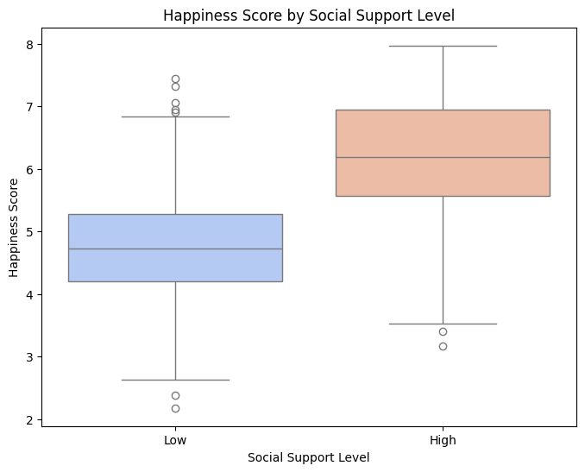Observations:
- Countries with high ‘Social Support’ consistently reported higher happiness scores, confirming the importance of strong interpersonal and societal networks.
- This validated our initial findings from the pairplot and correlation matrix.

Q5: How do freedom, wealth, and life expectancy together explain happiness?
We created a scatter plot with:
- X-axis: Wealth (GDP per Capita)
- Y-axis: Life Expectancy
- Hue: Happiness Score
- Style: Freedom (binned into four categories)
sns.scatterplot(
data=df[df["Country"] != "Haiti"],
x='Wealth', y='Life Expectancy',
hue='Happiness', style='Freedom Category'
)
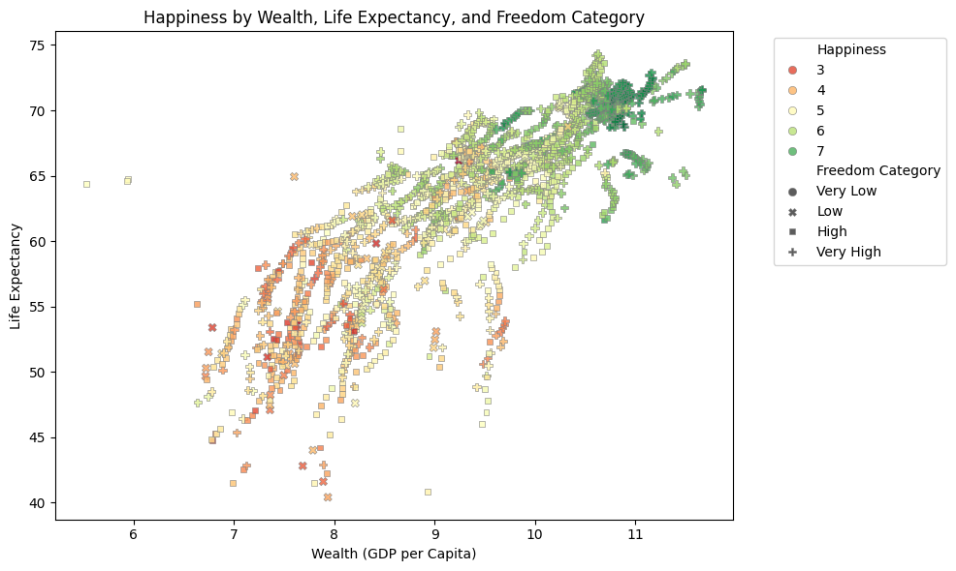Observations:
- Countries with freedom scores > 0.5, wealth > 9 (≈$8,100 GDP per capita), and life expectancy above 60 years tend to cluster in the higher happiness range (6-7).
- Freedom appears to amplify the positive effect of wealth and health on happiness.
- Haiti was excluded due to being a major outlier with unusually low life expectancy (40 years on average).
Overall, this phase of the project deepened our u nderstanding of the key drivers of happiness and revealed important global patterns, validating our feature selection and shaping our machine learning approach.

Machine Learning: Model Selection and Evaluation

Feature Preparation
The dataset primarily consisted of numerical variables, with 'Country' being the only categorical/text feature. Since it had no missing values and wasn't directly relevant for prediction, we excluded it from modeling. We also dropped “Trust in Government” from the model as it had a very weak correlation with the happiness score. Data transformations (such as normalization or scaling) were selectively applied to certain numerical columns where necessary. Applying transformations indiscriminately to all features was found to reduce model performance, specifically lowering the R² score.

Model Framework
We initially considered classification models but quickly transitioned to regression-based models, as the target variable, Happiness, is continuous. Accordingly, we used regression evaluation metrics such as Mean Squared Error (MSE) and R² Score in place of classification reports.
To account for the dataset’s moderate size (1910 rows post-cleaning), we split it into 80% training and 20% testing sets to ensure a balanced tradeoff between model training and generalization.

Models Trained
We trained and evaluated five regression models to predict happiness scores using socioeconomic and emotional well-being indicators:
- Linear Regression
- K-Nearest Neighbors (KNN) Regressor
- Decision Tree Regressor
- Random Forest Regressor

Evaluation Metrics
Each model was evaluated using:
- R² Score (Coefficient of Determination): Measures how well the predictions approximate the actual values.
- Mean Squared Error (MSE): Quantifies the average squared differences between actual and predicted values.

Model Performance Summary

Model | R² Score | Mean Squared Error
Linear Regression | 0.779 | 0.281
KNN Regressor | 0.680 | 0.407
Decision Tree Regressor | 0.738 | 0.334
Random Forest Regressor | 0.888 | 0.143

The Random Forest Regressor achieved the best performance, with the highest R² score (0.888) and lowest MSE (0.143). This indicates that it was the most accurate model for capturing the complex relationships between happiness and its predictors. Its strengths include:
- Effectively handling nonlinear relationships
- Robustness to noise and outliers
- Automatic modeling of feature interactions
To mitigate potential overfitting, features such as ‘Trust in Government’, ‘Generosity’, ‘Positive Affect’, and ‘Negative Affect’ were removed in alternate model iterations. This adjustment resulted in only a marginal decrease in RMSE and R² scores, indicating limited impact on overall model performance.
To further reduce underfitting or overfitting, hyperparameter tuning was performed on the Random Forest Regressor using GridSearchCV. The following parameters were tested: number of estimators (50, 100, 200), maximum depth (None, 10, 20), minimum samples required to split an internal node (2, 5), minimum samples required at a leaf node (1, 2), and the number of features considered at each split ('auto', 'sqrt').
The optimal combination of hyperparameters was found to be: max depth of 20, max features set to 'sqrt', minimum samples per leaf of 1, minimum samples per split of 2, and 100 estimators. This configuration yielded an R² score of 0.885 and a mean squared error (MSE) of 0.146.

Visual Assessment of Predictions
To further assess model performance, we generated scatter plots comparing actual vs. predicted happiness scores. These visualizations provided insights into:
- Model bias (under- or over-prediction tendencies)
- Alignment of predictions with real values
- Spread and variance of errors
Each plot included:
- A red dashed diagonal line (y = x) representing perfect predictions
- Dots representing model predictions, ideally clustered tightly along the line
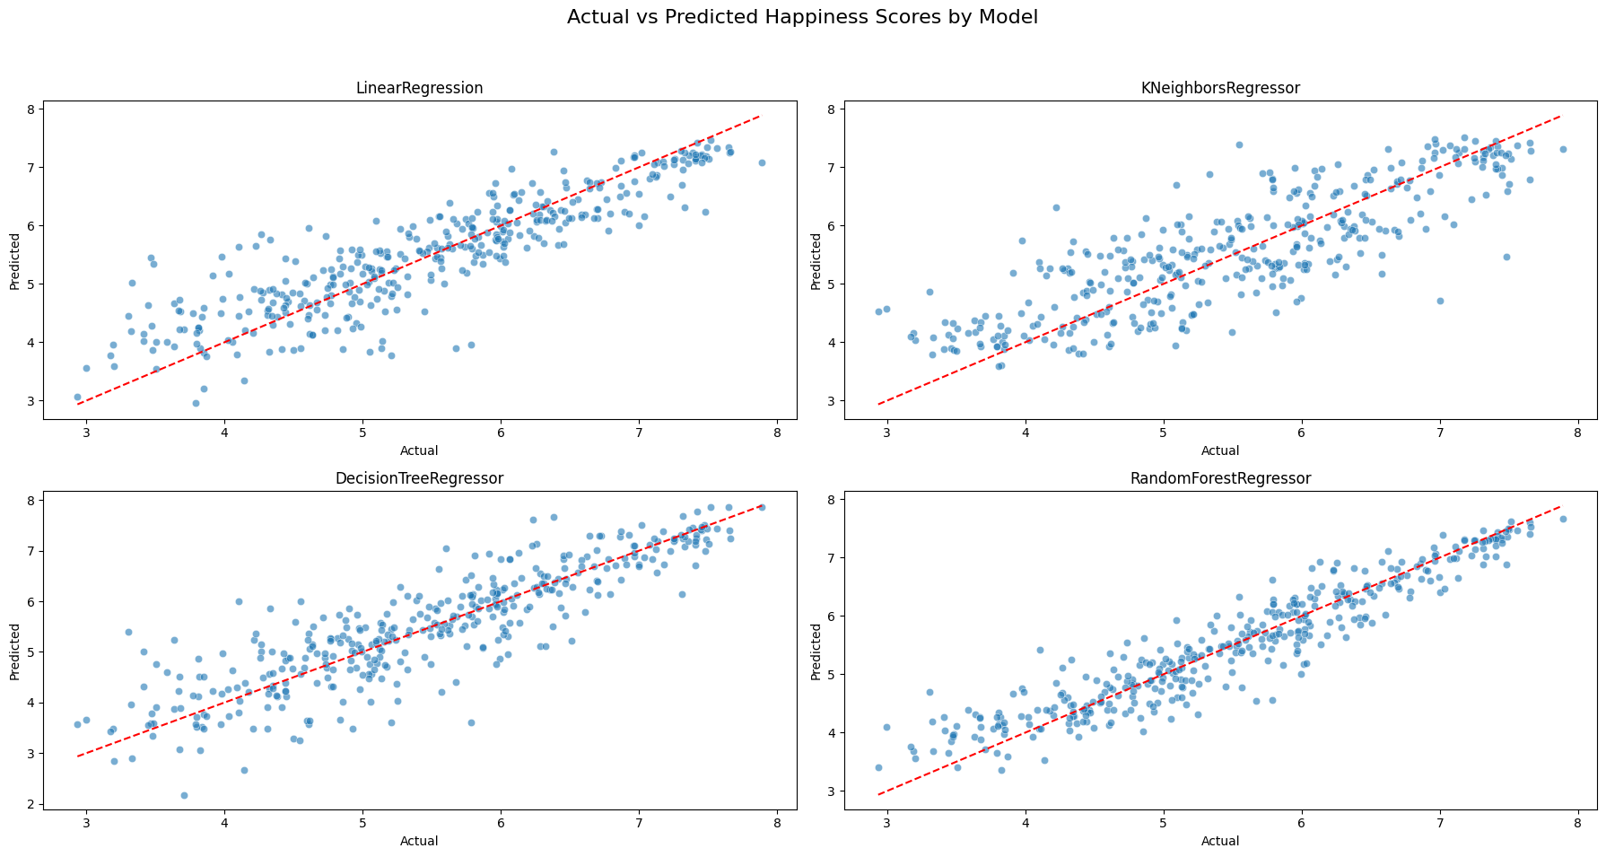
Models like Random Forest and Decision Tree displayed tighter clustering, indicating better predictive alignment than models like Linear Regression and KNeighbors Regressor.

Cross-Validation for Robustness
To ensure the generalizability of our findings, we applied 5-fold cross-validation to the training data. This approach helps evaluate model stability and reduces the risk of overfitting to a particular data split.
Cross-validation involves:
- Dividing the training data into 5 subsets
- Iteratively training on 4 subsets and validating on the remaining 1
- Computing the R² score for each fold and averaging the results

Cross-Validation Results
Model | CV R² Scores | Average CV R² Score
Linear Regression | [0.748, 0.795, 0.777, 0.777, 0.794] | 0.778
KNN Regressor | [0.669, 0.692, 0.693, 0.674, 0.628] | 0.671
Decision Tree Regressor | [0.734, 0.771, 0.732, 0.717, 0.749] | 0.741
Random Forest Regressor | [0.858, 0.878, 0.859, 0.850, 0.864] | 0.862
Random Forest again outperformed the other models, demonstrating high consistency and minimal variance across folds, confirming its robustness and reliability.

Takeaways and Conclusion
One of the most significant challenges encountered during the analysis was data cleaning. Initially, the decision to drop all rows containing missing values (‘NaN’) seemed straightforward. However, this approach resulted in the removal of far more data than anticipated. A missing value in just one column often led to the loss of complete and otherwise valuable rows. This highlighted the need for more refined strategies, such as targeted imputation or model-based handling of missing data, to preserve the integrity of the dataset.

Exploratory data analysis played a crucial role in understanding the relationships within the data. Visualization tools like pairplots and heatmaps were especially useful in identifying patterns and potential correlations between variables. These tools provided an accessible and intuitive way to assess which factors might be most influential, serving as a strong foundation before moving into machine learning applications.

When machine learning models were applied, it became clear that not all features contributed equally to model performance. Since all variables were numeric, classification models were not suitable, and regression models were used instead. Interestingly, removing some features had little to no impact on the key performance metrics, RMSE and R². This suggested that certain features carried minimal predictive value and could potentially be excluded to simplify the model.

However, other features proved to be critical. Wealth, social support, and life expectancy emerged as the most influential factors. When these variables were excluded from the models, there was a noticeable and substantial drop in performance. This confirmed their strong predictive power and emphasized their relevance in understanding health outcomes across different countries.

Future Steps

Looking ahead, the findings suggest that meaningful improvements in global health could be achieved by focusing on three primary areas. First, addressing poverty remains fundamental, as economic conditions are strongly tied to health and well-being. Second, expanding access to robust social support systems can enhance quality of life and resilience, particularly in vulnerable populations. Lastly, investments in healthcare services that increase life expectancy, such as preventive care, nutrition, and chronic disease management, are essential for long-term progress.

These directions not only align with the data-driven insights from the model but also offer a practical path forward for policymakers and development organizations aiming to improve public health outcomes on a global scale.

References

Data Source:
https://raw.githubusercontent.com/csbfx/cs133/main/world_happiness_2005-2021.csv

Presentation:
https://docs.google.com/presentation/d/1XXyCFKxorkFgHFJPZ38JJN0-XaPfU5slc1A5NS0CiYU/edit?usp=sharing

Colab Code: https://colab.research.google.com/drive/1O2wOxVzBzZMH8bc0ZXl-rTUf5QzLjRGF?usp=sharing

